AP Chemistry Summer Assignment

 |  | Due Date
Topic 1 | Significant Figures
Topic 2 | Metric and Temperature Conversions
Topic 3 | Nomenclature
Topic 4 | Atomic Structure
Topic 5 | Writing and Balancing Chemical Equations
Topic 6 | Moles and Stoichiometry
Topic 7 | Graphing and Data Analysis
Topic 8 | Particulate Drawings
Topic 9 | Elements and Ions to Memorize (Prepare Flash Cards)

Timeline for completing assignment:
July 9-15: Topic 1 and Topic 2, Memorize elements/symbols on the elements and ions to memorize the left column on the ions list by name page
July 16-22: Topic 3 and Topic 4, Memorize the middle column on the ions list by name page
July 23-29: Topic 5 and Topic 6, Memorize the right column on the ions list by name page
July 30-August 5: Topic 7 and Topic 8, Review all ions and elements and take practice quiz #1
August 6-16: Review all ions and elements and take practice quizzes #2-#4
August 17: Summer assignment is due at the beginning of class
August 18: Quiz on all ions and element symbols assigned

Topic 1: Significant Figures

- Determine the number of significant figures in each of the following:
  - 0.7540 __________________
  - 12500 __________________
  - 1000.01 __________________
  - 1200 __________________
  - $1.04 × {10}^{3}$ __________________
  - $0.0080050$ __________________

- Perform the following calculations and round to the appropriate number of significant figures:
  - $34.66+333.0$ __________________
  - $1.23+9.66$ __________________
  - $455-1.22$ __________________
  - $18.2×1.998$ __________________
  - $10.2÷1.34$ __________________
  - $\frac{100.23+59.4}{5.22}$ __________________

- Round each of the following numbers to three significant figures:
  - 167.789 __________________
  - 0.00000445345 __________________
  - 25.0545 __________________
  - 3.1415926536 __________________
  - 8504.0435 __________________
  - 14.4355 __________________

Topic 2: Metric and Temperature Conversions

- Use dimensional analysis (factor-label method) to make the following metric conversions:
  - 3.40 m to cm $_______________× ______________=_____________________$
  - 289 cm to nm $_______________× ______________× ______________=_____________________$
  - 125145 J to kJ $_______________× ______________=_____________________$
  - 164 mg to g $_______________× ______________=_____________________$
  - 46.5 mL to L $_______________× ______________=_____________________$
- Make the following temperature conversions:
  - 162˚F to ˚C __________________________________________
  - 0.0 ˚F to K __________________________________________
  - -18 ˚C to K __________________________________________
  - 212 K to ˚C __________________________________________
  - 98.6 ˚F to K __________________________________________

Topic 3: Nomenclature

- Name or write the formula for the following ionic compounds:
a. LiCl |  | g. tin(II) bromide
b. Mg(OH)2 |  | h. potassium phosphate
c. K3P |  | i. nickel(II) perchlorate
d. Fe2O3 |  | j. sodium hydroxide
e. FeO |  | k. zinc phosphate
f. ZnCl2 |  | l. ammonium sulfate

- Name or write the formula for the following covalent compounds:
a. CO |  | e. nitrogen tribromide
b. CBr4 |  | f. tetraphosphorus decaoxide
c. SO2 |  | g. xenon hexafluoride
d. N2O4 |  | h. dicarbon tetrafluoride

- Name or write the formula for the following acids:
a. HCl |  | e. hydrobromic acid
b. HNO3 |  | f. hydronitric acid
c. HC2H3O2 |  | g. phosphoric acid
d. H2SO4 |  | h. hydrosulfuric acid

Topic 4: Atomic Structure

- Determine the number of protons, neutrons and electrons in each of the following:

  - ${}_{19}^{39}K$ protons: ___________ neutrons: ___________ electrons: ___________
  - ${}_{11}^{23}{{Na}^{1+}}$ protons: ___________ neutrons: ___________ electrons: ___________
  - ${}_{82}^{208}{Pb}$ protons: ___________ neutrons: ___________ electrons: ___________
  - ${}_{15}^{33}{P^{3-}}$ protons: ___________ neutrons: ___________ electrons: ___________

Write the symbol for the atom that contains
  - 24 protons, 21 electrons and 24 neutrons
  - 34 protons, 45 neutrons, 34 electrons
  - 8 protons, 10 neutrons, 10 electrons
- What experimental evidence supports these statements?
  - The nucleus of an atom is small.
  - The atom consists of both positive and negative charges.
  - The nucleus of the atom is positive.

Topic 5: Writing and Balancing Chemical Equations

- Balance the following chemical equations:
  - _____ Cr(s) + _____ O2(g) →_____Cr2O3(s)
  - _____ SiH4(g) → _____ Si(s) + _____ H2(g)
  - _____ SO3(g) → _____ SO2(g) + _____ O2(g)
  - _____ Pb(NO3)2(s) → _____ PbO(s) + _____ NO2(g) + _____ O2(g)
  - _____ C3H8(g) + _____ O2(g) →_____ CO2(g) + _____ H2O(g)
  - _____ C2H5OH(l) + _____ O2(g) →_____ CO2(g) + _____ H2O(g)

- Write a balanced chemical equation for each of the following reaction descriptions:
  - When solid calcium carbonate is heated, solid calcium oxide and gaseous carbon dioxide are formed.

  - Aluminum metal reacts with oxygen to form solid aluminum oxide.

  - When solid mercury(II) sulfide is heated with oxygen, liquid mercury metal and gaseous sulfur dioxide are produced.

  - When aqueous solutions of aluminum sulfate and barium chloride are mixed, solid barium sulfate and aqueous aluminum chloride are formed.

  - Solid sodium bicarbonate reacts with hydrochloric acid to produce sodium chloride, water, and carbon dioxide gas.

  - Gaseous ammonia and oxygen react to produce nitrogen monoxide gas and water

Topic 6: Moles and Stoichiometry

- Vinegar is a dilute solution of acetic acid, CH3COOH.
  - Calculate the molar mass of acetic acid.

  - How many molecules of CH3COOH are contained within 43.4 g of acetic acid?

  - How much would 0.450 moles of acetic acid weigh?

- How many moles of hydrogen gas can be produced if 1.35 g of solid zinc reacts with excess hydrochloric acid according to the equation
Zn + 2 HCl → H2 + ZnCl2

- The reaction for the combustion of propane is
_____ C3H8 + _____ O2 → _____CO2 + _____H2O
  - If 20.0 g of C3H8 and 20.0 g of O2 are reacted, how many moles of CO2 can be produced?

- If 20.0 g of C3H8 and 80.0 g of O2 are reacted, how many grams of CO2 can be produced

Topic 7: Graphing and Data Analysis

- When anhydrous calcium chloride is dissolved in water, the temperature of the system changes. A student obtains the following data when dissolving increasing amounts of CaCl2 into 100 mL of water:
Mass of CaCl2 dissolved, g | 0.91 | 2.94 | 5.92 | 8.81 | 10.89
ΔT, ˚C | 1.8 | 6.6 | 12.8 | 18.9 | 23.2

Plot the data on the graph below. Choose an appropriate scale, and label the axes appropriately.

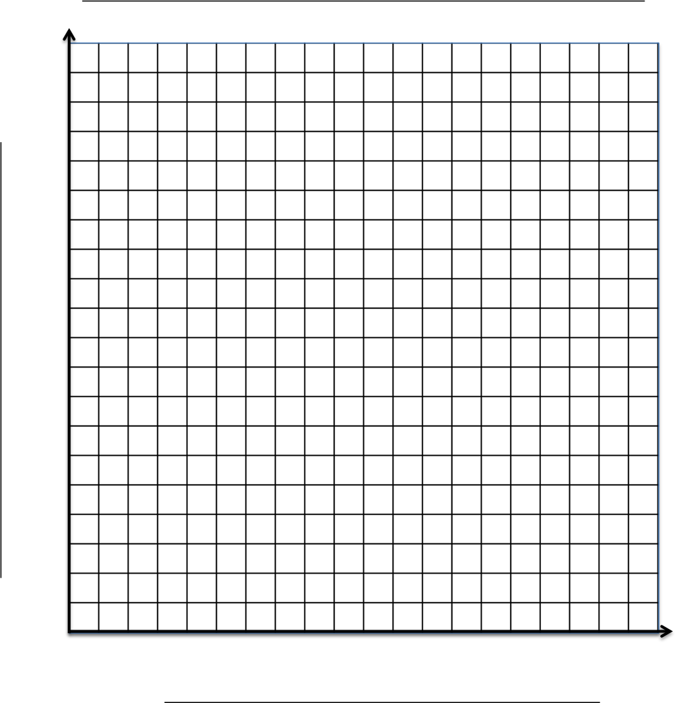

Refer to the graph to answer the following questions.

Independent Variable: _____________________________________

Dependent Variable: _____________________________________

Provide a descriptive title for the graph: ____________________________________________________________

- Describe the relationship between grams of calcium chloride salt and change in temperature in a sentence.

- Draw a line of best fit. Determine its slope, including units.

- Predict the change in temperature when (Look this up)

  - 4.33 g of CaCl2 are dissolved

  - 9.56 g of CaCl2 are dissolved

  - 15.4 g of CaCl2 are dissolved

- Predict what mass of CaCl2 will result in (look this up)
  - a 12.4˚C change in temperature

  - a 44.9 ˚C change in temperature

Topic 8: Particulate Diagrams

- Consider the synthesis of nitrogen dioxide
2 NO + 1 O2 → 2 NO2
  - In the diagram below, nitrogen atoms are represented with squares and oxygen atoms are represented with circles. Using the conservation of matter, draw what you would expect to find in the reaction vessel once the reaction is complete.

Before Reaction: After Reaction







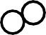
Limiting Reactant: Excess Reactant:

Explanation

  - Consider the same reaction, with different starting quantities. Draw the contents of the reaction vessel after the reaction is complete.

Before Reaction: After Reaction
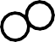

Limiting Reactant: Excess Reactant:

Explanation

Topic 9: Elements and Ions to Memorize

- Prepare flash cards for the following elements/ions and their symbols
C2H3O2- | acetate
ClO3- | chlorate
ClO2- | chlorite
CN- | cyanide
HCO3- | bicarbonate
OH- | Hydroxide
NO3- | nitrate
NO2- | nitrite
ClO4- | perchlorate
MnO4- | permanganate
SCN- | thiocyanate
CO32- | carbonate
CrO42- | chromate
SO42- | sulfate
SO32- | sulfite
PO43- | phosphate
PO33- | phosphite
NH4+ | ammonium

H | hydrogen
He | helium
Li | lithium
Be | beryllium
B | boron
C | carbon
N | nitrogen
O | oxygen
F | fluorine
Ne | neon
Na | sodium
Mg | magnesium
Al | aluminum
Si | silicon
P | phosphorus
S | sulfur
Cl | chlorine
Ar | argon
K | potassium
Ca | calcium
Cr | chromium
Mn | manganese
Fe | iron
Cu | Copper
Zn | zinc
Ag | silver
Pb | lead

Preparation for AP Chemistry Period Date

I O N S L I S T B Y N A M E

Acetate | −  C2H3O2 or  CH3COO⁻ | Hydrogen sulfate,  bisulfate | −  HSO4 | Oxide | O2−
Aluminum | Al3+ | Hydronium | H3O⁺ | Perbromate | −  BrO4
Ammonium | +  NH4 | Hydroxide | OH⁻ | Perchlorate | −  ClO4
Barium | Ba2+ | Hypobromite | BrO⁻ or OBr⁻ | Periodate | −  IO4
Bromate | −  BrO3 | Hypochlorite | ClO⁻ or OCl⁻ | Permanganate | −  MnO4
Bromide | Br⁻ | Hypoiodite | IO⁻ or OI⁻ | Peroxide | 2−  O2
Bromite | −  BrO2 | Iodate | −  IO3 | Phosphate | 3−  PO4
Calcium | Ca2+ | Iodide | I− | Phosphite | 3−  PO3
Carbonate | 2−  CO3 | Iodite | −  IO2 | Potassium | K+
Chlorate | −  ClO3 | Iron (II), ferrous | Fe2+ | Silver | Ag⁺
Chloride | Cl⁻ | Iron (III), ferric | Fe3+ | Sodium | Na⁺
Chlorite | −  ClO2 | Lead (II), plumbous | Pb2+ | Strontium | Sr2+
Chromate | 2−  CrO4 | Lead (IV), plumbic | Pb4+ | Sulfate | 2−  SO4
Copper (I), cuprous | Cu⁺ | Lithium | Li⁺ | Sulfide | S2−
Copper (II), cupric | Cu2+ | Magnesium | Mg2+ | Sulfite | 2−  SO3
Cyanide | CN⁻ | Mercury (I), mercurous | 2+  Hg2 | Thiocyanate | SCN⁻
Dichromate | 2−  Cr2O7 | Mercury (II), mercuric | Hg2+ | Thiosulfate | 2−  S2O3
Fluoride | F− | Nickel | Ni2+ | Tin (II), stannous | Sn2+
Hydrogen | H+ | Nitrate | −  NO3 | Tin (IV), stannic | Sn4+
Hydrogen carbonate, bicarbonate, | −  HCO3 | Nitrite | −  NO2 | Zinc | Zn2+

Preparation for AP Chemistry Period Date

P R A C T I C E I O N S Q U I Z - 1

Name | Formula |  | Name | Formula |  | Name | Formula
Hypobromite |  |  | Hydrogen |  |  | Dichromate
Iodate |  |  | Thiocyanate |  |  | Nitrate
Permanganate |  |  | Perbromate |  |  | Bromate
Sodium |  |  | Nitrite |  |  | Bicarbonate,
Ammonium |  |  | Hypoiodite |  |  | Chromate
Bisulfate |  |  | Nickel |  |  | Hydronium
Phosphite |  |  | Chlorate |  |  | Peroxide
Iodite |  |  | Stannic |  |  | Ferric
Silver |  |  | Oxide |  |  | Chloride
Cuprous |  |  | Fluoride |  |  | Strontium
Phosphate |  |  | Cyanide |  |  | Periodate
Iodide |  |  | Thiosulfate |  |  | Potassium
Sulfite |  |  | Hydroxide |  |  | Chlorite
Lithium |  |  | Mercuric |  |  | Ferrous
Calcium |  |  | Cupric |  |  | Bromide
Sulfide |  |  | Hypochlorite |  |  | Perchlorate
Acetate |  |  | Plumbic |  |  | Sulfate
Mercurous |  |  | Stannous |  |  | Zinc
Bromite |  |  | Plumbous |  |  | Barium
Aluminum |  |  | Carbonate |  |  | Magnesium

Preparation for AP Chemistry Period Date

P R A C T I C E I O N S Q U I Z - 2

Name | Formula |  | Name | Formula |  | Name | Formula
Ferrous |  |  | Hydronium |  |  | Iodate
Plumbous |  |  | Nitrite |  |  | Cupric
Calcium |  |  | Iodite |  |  | Phosphite
Bromite |  |  | Perbromate |  |  | Oxide
Thiosulfate |  |  | Bicarbonate, |  |  | Chlorate
Sodium |  |  | Zinc |  |  | Hypochlorite
Chlorite |  |  | Barium |  |  | Permanganate
Chromate |  |  | Perchlorate |  |  | Dichromate
Strontium |  |  | Peroxide |  |  | Plumbic
Sulfite |  |  | Periodate |  |  | Nickel
Stannous |  |  | Mercuric |  |  | Mercurous
Hydroxide |  |  | Silver |  |  | Fluoride
Nitrate |  |  | Phosphate |  |  | Potassium
Cyanide |  |  | Thiocyanate |  |  | Sulfate
Aluminum |  |  | Bromate |  |  | Lithium
Sulfide |  |  | Carbonate |  |  | Ammonium
Bromide |  |  | Bisulfate |  |  | Acetate
Magnesium |  |  | Chloride |  |  | Stannic
Hypobromite |  |  | Hydrogen |  |  | Hypoiodite
Iodide |  |  | Cuprous |  |  | Ferric

Preparation for AP Chemistry Period Date

P R A C T I C E I O N S Q U I Z - 3

Name | Formula |  | Name | Formula |  | Name | Formula
Perchlorate |  |  | Cuprous |  |  | Mercurous
Iodide |  |  | Zinc |  |  | Silver
Plumbous |  |  | Perbromate |  |  | Thiosulfate
Calcium |  |  | Bicarbonate, |  |  | Fluoride
Thiocyanate |  |  | Oxide |  |  | Ferric
Bromate |  |  | Stannic |  |  | Hypochlorite
Nitrite |  |  | Nickel |  |  | Potassium
Sulfide |  |  | Hydronium |  |  | Nitrate
Chromate |  |  | Ferrous |  |  | Peroxide
Sulfite |  |  | Hypobromite |  |  | Cyanide
Sulfate |  |  | Iodite |  |  | Mercuric
Phosphate |  |  | Lithium |  |  | Hydrogen
Phosphite |  |  | Ammonium |  |  | Permanganate
Barium |  |  | Strontium |  |  | Chlorate
Sodium |  |  | Dichromate |  |  | Chloride
Hypoiodite |  |  | Plumbic |  |  | Chlorite
Cupric |  |  | Acetate |  |  | Carbonate
Periodate |  |  | Magnesium |  |  | Hydroxide
Aluminum |  |  | Iodate |  |  | Bisulfate
Stannous |  |  | Bromite |  |  | Bromide

Preparation for AP Chemistry Period Date

P R A C T I C E I O N S Q U I Z - 4

Name | Formula |  | Name | Formula |  | Name | Formula
Aluminum |  |  | Sodium |  |  | Peroxide
Perbromate |  |  | Bromite |  |  | Phosphate
Sulfide |  |  | Lithium |  |  | Hypochlorite
Cuprous |  |  | Chloride |  |  | Nitrate
Nitrite |  |  | Thiocyanate |  |  | Phosphite
Calcium |  |  | Nickel |  |  | Ferric
Potassium |  |  | Oxide |  |  | Strontium
Sulfite |  |  | Bromate |  |  | Fluoride
Hydroxide |  |  | Sulfate |  |  | Stannic
Chlorite |  |  | Hydronium |  |  | Chromate
Chlorate |  |  | Bicarbonate, |  |  | Ferrous
Zinc |  |  | Hydrogen |  |  | Plumbous
Mercuric |  |  | Thiosulfate |  |  | Carbonate
Stannous |  |  | Silver |  |  | Bisulfate
Periodate |  |  | Perchlorate |  |  | Hypoiodite
Bromide |  |  | Mercurous |  |  | Permanganate
Magnesium |  |  | Iodite |  |  | Iodide
Cyanide |  |  | Iodate |  |  | Cupric
Barium |  |  | Hypobromite |  |  | Dichromate
Ammonium |  |  | Plumbic |  |  | Acetate

